

**Case IH Agriculture Equipment, Inc**.

**For More Information, contact:**

Dan Danford 262/636-7359

[dan.danford@caseih.com](mailto:dan.danford@caseih.com)

or

Ryann Greve 262/636-5921

[ryann.greve@caseih.com](mailto:ryann.greve@caseih.com)

**Press Materials**

**CASE IH EXPANDS CVT OFFERING INTO MAXXUM 110-130 MODELS**

**RACINE, Wis.** (August 27, 2013)

Case IH announces that Case IH Continuously Variable Transmissions (CVT) technology is now available for the Maxxum® tractor line up, with Maxxum 110, 120 and 130 CVT options. First introduced into the North American market with the Puma family in 2008, Case IH CVT simplifies tractor operation while also delivering the best balance of power and fuel efficiency.

"Case IH continues to deliver on customer requests by taking the multi-purpose Maxxum tractor, which is known for its ability to handle large workloads, and furnishing it with technology to improve engine performance and fuel efficiency," says Dave Bogan, marketing manager for Puma and Maxxum tractors. “But what customers tell us they really appreciate is how easy the Case IH CVT is to use, even for inexperienced drivers. There’s no programming required; you set the speed and direction you want to go and the tractor does the rest.”

**Efficient Power Built In**

CVT combines the stepless speed variability of a hydrostatic transmission with the mechanical efficiency of a traditional gear transmission. “It delivers power to the ground efficiently at every speed, for the ultimate in smooth, stepless shifting,” says Bogan. From creeper speeds as low as 98 feet per hour for vegetable growers, all the way up to 30 miles per hour for transport operations.”

Case IH offers an active stop feature that is especially popular, according to Bogan. “You simply pull the MultiFunction Handle all the way back, and it will stop the tractor without having to push the clutch. This makes it easier to operate the tractor, and it makes starting and stopping as simple as driving your pickup truck.”

This functionality also applies to the foot throttle and is especially useful when backing the tractor up to hitch to implements. Not only is this process easier, it also is safer.

All Maxxum tractors are equipped with standard Power Boost, which provides additional engine power of up to 20 horsepower to maintain working speeds in tough crop conditions or on inclines, or to provide more power for roading or for mobile hydraulics or PTO applications. Maxxum CVT tractors also feature increased hydraulic capacity for more responsive implement and steering control.

**Even Better Operator Environment**

Adding to the ease of operation for new Maxxum MultiController models is an updated Case IH Multifunction Handle that simplifies operation. Redesigned buttons are now raised and backlit, and sized to differentiate functions, based on feedback from operators. You can tell the buttons apart by touch alone to make operation even simpler.

Other cab enhancements for Maxxum CVT, Maxxum Multicontroller and Puma models include a newly designed headliner control bank, featuring AC controls, relocated into a more natural line of sight when operating the tractor. The headliner also has 3 additional slots – 1 for radio and 2 for additional storage. A tinted rear window has been added to the suspended cab, which is standard on Maxxum Multicontroller and CVT models. Operators will also appreciate new left-hand soft trim, a storage net below the optional instructor seat and elastic straps on the instructor seat’s back rest. There is deluxe radio option with Bluetooth, as well as optional factory fit carpet.

*Case IH is a global leader in agricultural equipment, committed to collaborating with its customers to develop the most powerful, productive, reliable equipment – designed to meet today’s agricultural challenges. Challenges like feeding an expanding global population on less land, meeting ever-changing government regulations and managing input costs. With headquarters in the United States, Case IH has a network of dealers and distributors that operates in over 160 countries. Case IH provides agricultural equipment systems, flexible financial service offerings and parts and service support for professional farmers and commercial operators through a dedicated network of professional dealers and distributors. Productivity enhancing products include tractors; combines and harvesters; hay and forage equipment; tillage tools; planting and seeding systems; sprayers and applicators; site-specific farming tools and utility vehicles. Case IH is a brand of CNH (NYSE: CNH), a majority-owned subsidiary of Fiat   
Industrial S.p.A. (FI.MI).*

700 State Street, Racine, WI 53404 USA (more)

###

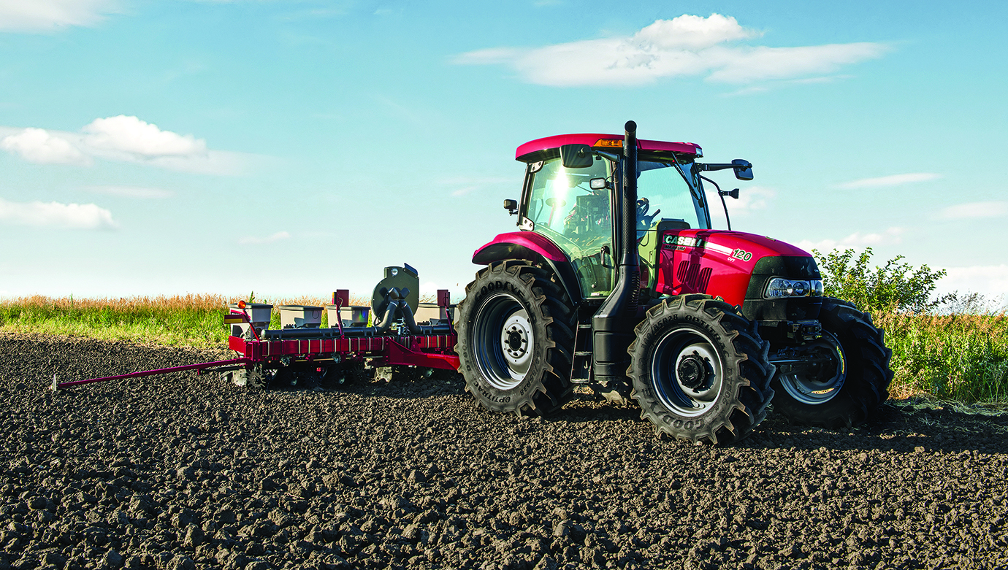

**Photo Caption:** Case IH continuously variable transmissions (CVT) technology is now available on Case IH Maxxum 110, 120 and 130 models, giving operators the best balance of power and fuel efficiency.